# **String**

1. **Write a program in C to find the length of a string without using library functions.**

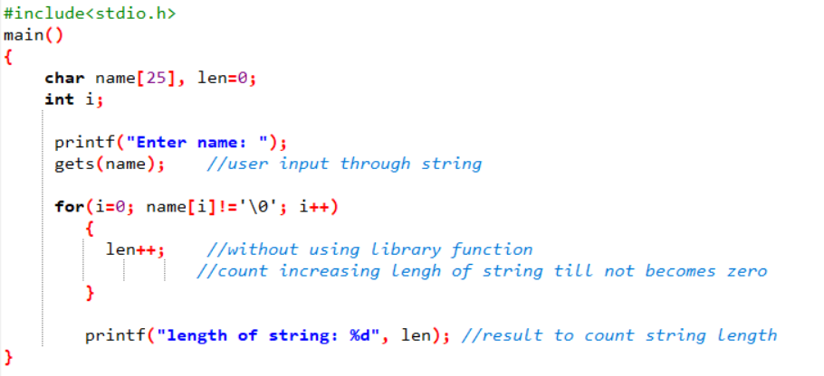

**Output:**

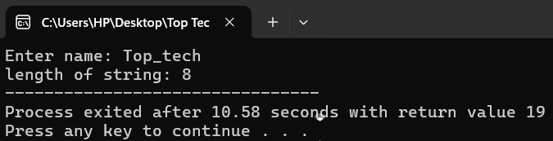

1. 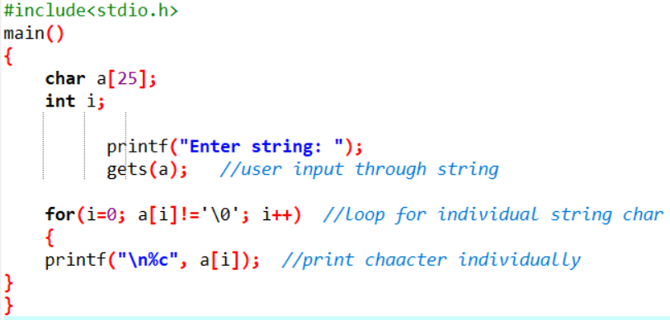**Write a program in C to separate individual characters from a string.**

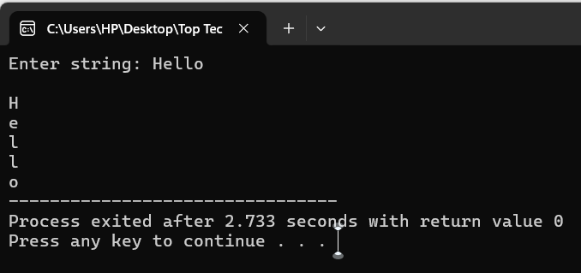**Output:**

1. **Write a program in C to print individual characters of a string in reverse order.**

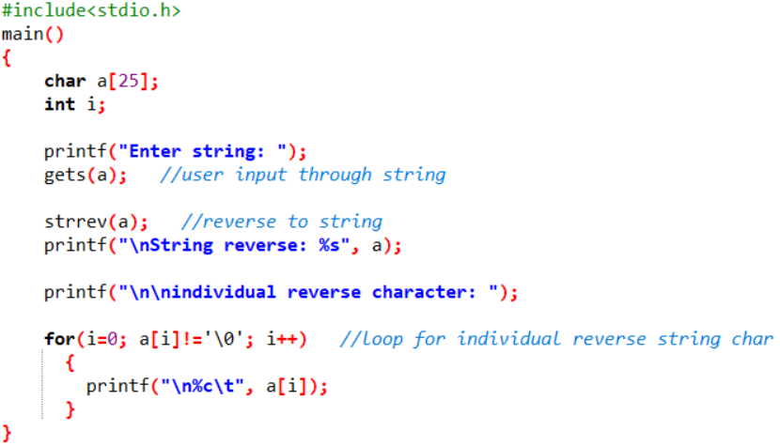

**Output:**

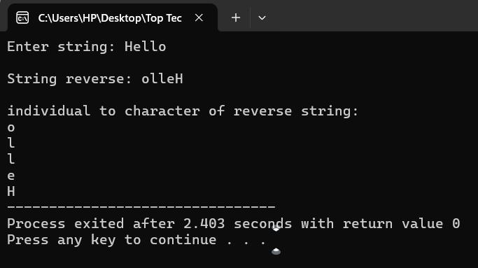

1. 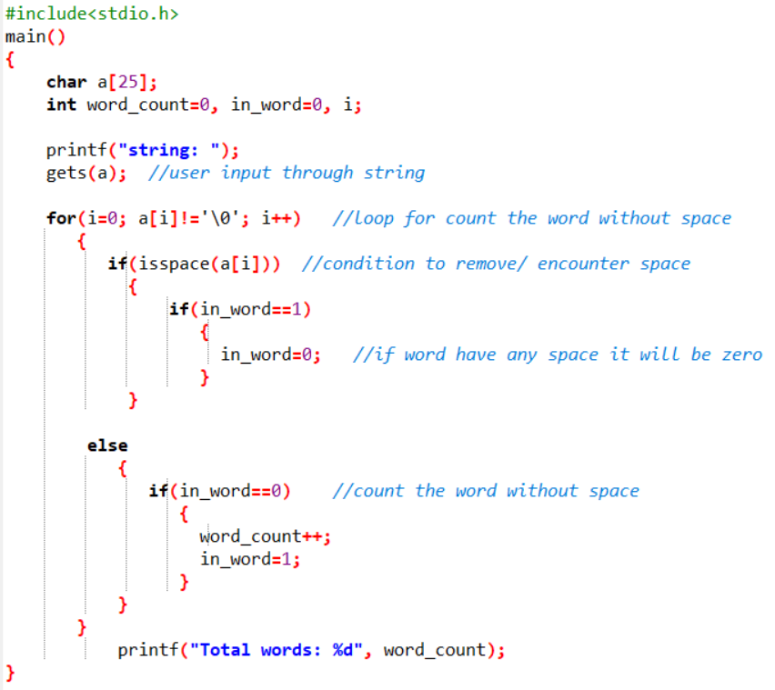**Write a program in C to count the total number of words in a string.**

**Output:**

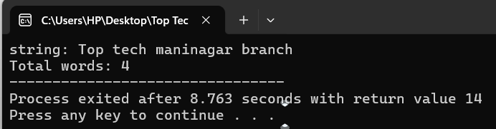

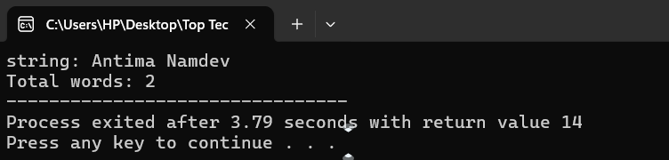

**5. Write a program in C to compare two strings without using string library functions.**

**6. Write a program in C to count the total number of alphabets, digits and special characters in a string.**

**7. Write a program in C to copy one string to another string.**

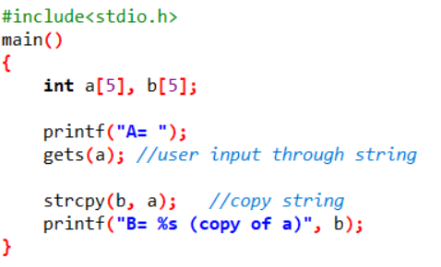

**Output:**

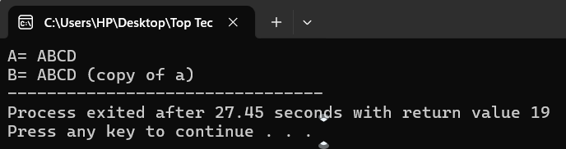

**8. Write a program in C to count the total number of vowels or consonants in a string.**

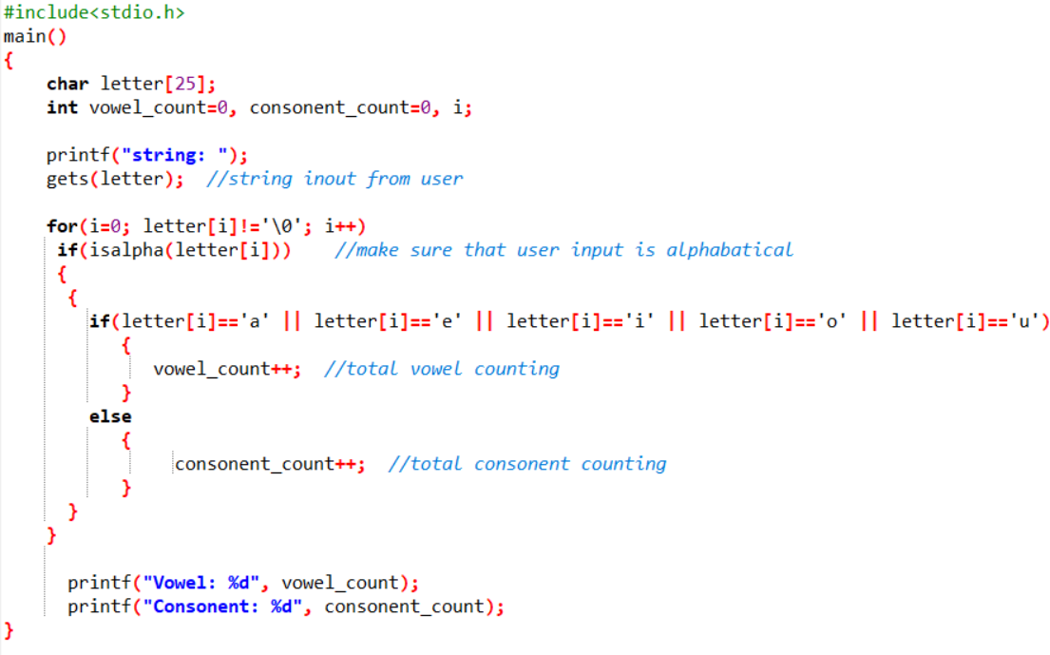

**Output:**

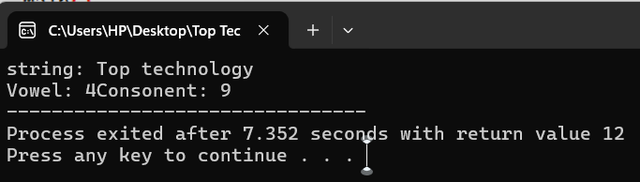

**9. Write a program in C to find the maximum number of characters in a string.**

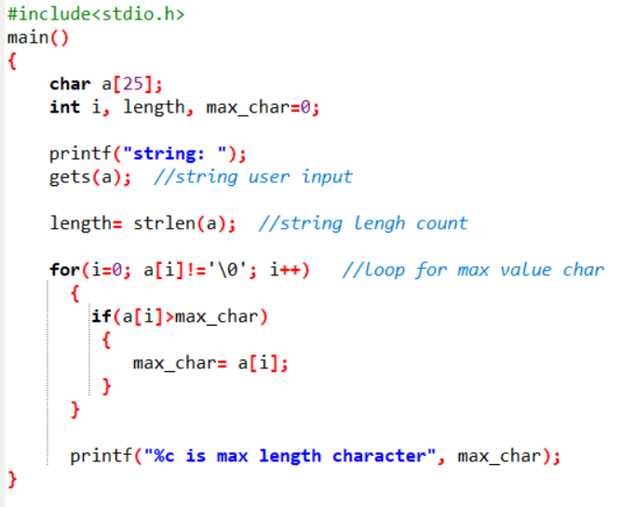

**Output:**

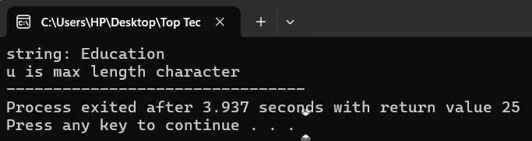

**10. Write a program in C to extract a substring from a given string.**

**11. Write a program in C to read a sentence and replace lowercase characters with uppercase and vice versa.**

**12. Write a program in C to find the number of times a given word 'is' appears in the given string.**

**13. Write a program in C to remove characters from a string except alphabets.**

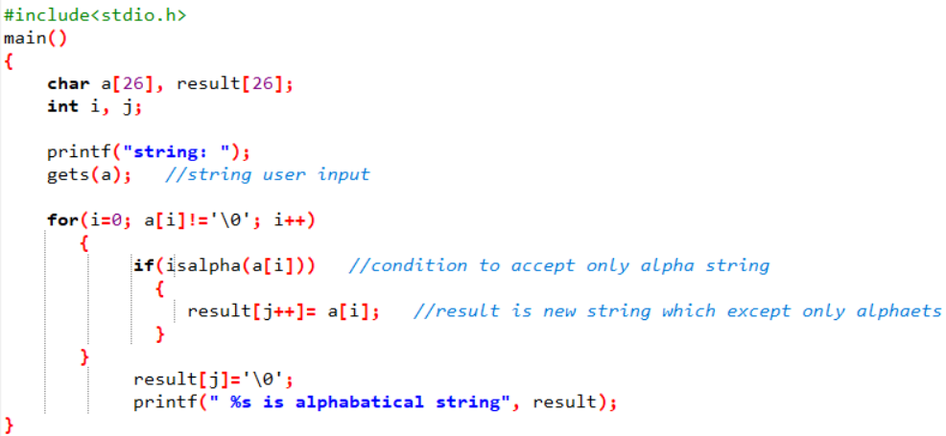

**Output:**

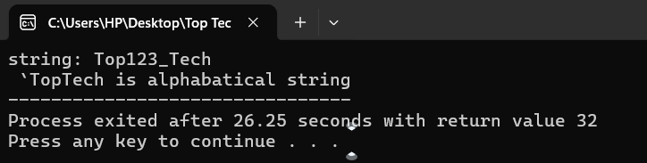

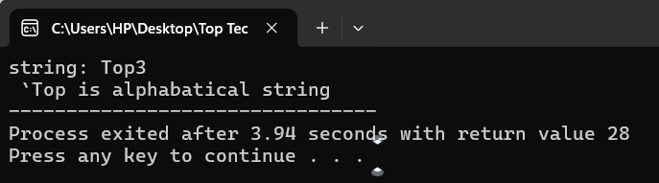

**14. Write a program in C to combine two strings manually.**

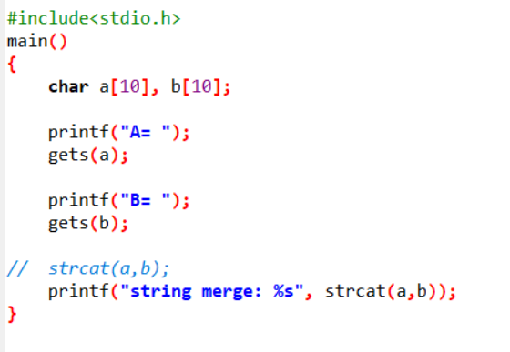

**Output:**

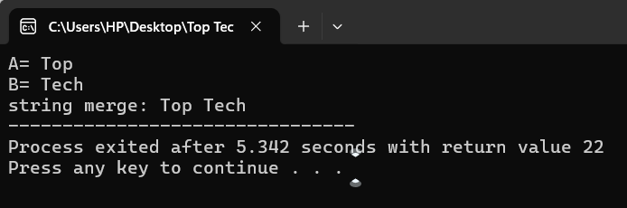

**15. Write a program in C to find the largest and smallest words in a string.**